Bài thực hành 8

Trần Văn Quyền

MSSV: 19574802010166

Câu 1:

import cv2

import matplotlib.pyplot as plt

img = cv2.imread("D:\\Tran Quyen\\quyen.png")

x1 = int(input("Nhap vao toa do x1: "))

y1 = int(input("Nhap vao toa do y1: "))

chieu_rong = int(input("Nhap vao chieu rong: "))

chieu_cao = int(input("Nhap vao chieu cao: "))

anh_cat = img[y1:y1 + chieu_cao, x1:x1 + chieu_rong]

anh_xam = cv2.cvtColor(anh_cat, cv2.COLOR_BGR2GRAY)

gau = cv2.GaussianBlur(anh_xam,(3,3), 0)

thich_nghi = cv2.adaptiveThreshold(anh_xam, 255, cv2.ADAPTIVE_THRESH_GAUSSIAN_C, cv2.THRESH_BINARY, 11, 2)

plt.subplot(1,3,1), plt.imshow(anh_cat, cmap = 'gray'), plt.title("Anh cat")

plt.subplot(1,3,2), plt.imshow(gau, cmap = 'gray'), plt.title("Loc anh")

plt.subplot(1,3,3), plt.imshow(thich_nghi, cmap = 'gray'), plt.title("Phan nguong")

plt.show()

cv2.waitKey(0)

cv2.destroyAllWindows()

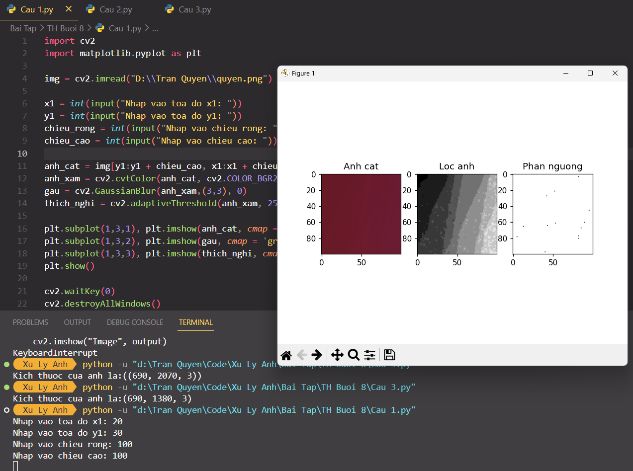

Câu 2:

import cv2

import numpy as np

img = cv2.imread("D:\\Tran Quyen\\quyen.png")

anh_xam = cv2.cvtColor(img, cv2.COLOR_BGR2GRAY)

x = int(input("Nhap vao gia tri phan nguong: "))

_,nhi_phan = cv2.threshold(anh_xam, x, 255, cv2.THRESH_BINARY)

kernel = np.ones((3,3), np.uint8)

dong_anh = cv2.erode(img, kernel, iterations=1)

mo_anh = cv2.dilate(dong_anh, kernel, iterations=1)

grad_x = cv2.Sobel(anh_xam, cv2.CV_32F, 1, 0, ksize=3)

grad_y = cv2.Sobel(anh_xam, cv2.CV_32F, 0, 1, ksize=3)

abs_grad_x = cv2.convertScaleAbs(grad_x)

abs_grad_y = cv2.convertScaleAbs(grad_y)

grad = cv2.addWeighted(abs_grad_x, 0.5, abs_grad_y, 0.5, 0)

cv2.imshow("Anh phan nguong", nhi_phan)

cv2.imshow("Tach bien Sobel", grad)

cv2.imshow("Dong anh", dong_anh)

cv2.imshow("Mo anh", mo_anh)

while True:

if cv2.waitKey(1) == ord('q'):

cv2.imwrite("D:\\Tran Quyen\\tachbien.png", grad)

if cv2.waitKey(1) == ord('s'):

break

cv2.destroyAllWindows()

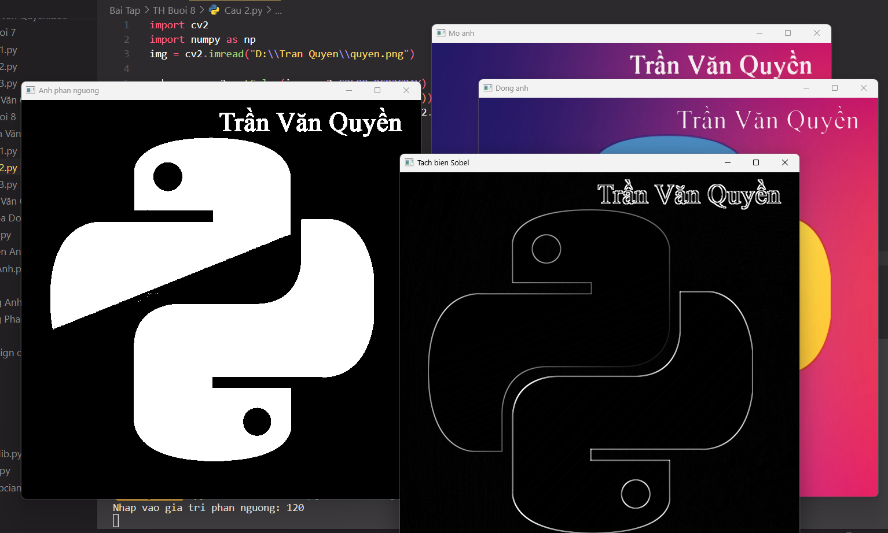

Câu 3:

import cv2

img = cv2.imread("D:\\Tran Quyen\\quyen.png")

tx = 1

def get_tx(x):

global tx

tx = x

ty = 1

def get_ty(x):

global ty

ty = x

cv2.namedWindow("Image")

cv2.createTrackbar('Tx','Image',0,50,get_tx)

cv2.createTrackbar('Ty','Image',0,50,get_ty)

while True:

output = cv2.resize(img, None, fx = tx, fy = ty, interpolation = cv2.INTER_LINEAR)

cv2.imshow("Image", output)

if cv2.waitKey(1) == ord('s'):

cv2.imwrite("D:\\Tran Quyen\\anh.png")

if cv2.waitKey(1) == ord('q'):

break

if cv2.waitKey(1) == ord('p'):

print("Kich thuoc cua anh la:{}".format(output.shape))

cv2.destroyAllWindows()

